Module-Wise Lab Workbook
Program: Test Automation Training (Selenium, PyTest, Python Automation, Robot Framework)
Courses covered:
- Selenium WebDriver with Python (Whizlabs)
- Python for Automation (Madecraft)
- Test Automation with Playwright (Python) & Robot Framework (Coursera)
Curriculum modules mapped: Milestone 1 (Selenium Fundamentals) · Milestone 2 (Unittest/PyTest/POM) · Milestone 3 (Python Automation, Web Scraping, REST API) · Milestone 4 (Robot Framework)
Environment: Python 3.13.5, Selenium 4.49.0 (upgraded), Chrome 153.0.8010.48, Windows 11, run via cmd + Notepad (no IDE).

Module 1: Selenium Fundamentals & Web Interactions
(from Selenium WebDriver with Python — Weeks 1–2)

Experiment 1.1 — Locator Strategies and Login Automation
Problem statement: Automate login to a demo e-commerce site using three different locator strategies and verify successful navigation.
Objective: Demonstrate use of By.NAME, By.XPATH, and confirm the flow completes by capturing the resulting URL.
Tools/software/concepts used: Python 3, Selenium WebDriver, ChromeDriver (auto-managed via Selenium Manager), By locator strategies, ChromeOptions.
Source code:
from selenium import webdriver
from selenium.webdriver.common.by import By
from selenium.webdriver.chrome.options import Options
import time

options = Options()
options.add_argument("--start-maximized")
driver = webdriver.Chrome(options=options)
driver.get("https://tutorialsninja.com/demo/index.php?route=account/login")

driver.find_element(By.NAME, "email").send_keys("testuser@example.com")
driver.find_element(By.XPATH, "//input[@name='password']").send_keys("Test@1234")
driver.find_element(By.XPATH, "//input[@value='Login']").click()

time.sleep(2)
print("Current URL:", driver.current_url)

driver.quit()
Output:
Current URL: https://tutorialsninja.com/demo/index.php?route=account/login
Fig. 1(a),(b),(c): cmd output above + browser window with form filled
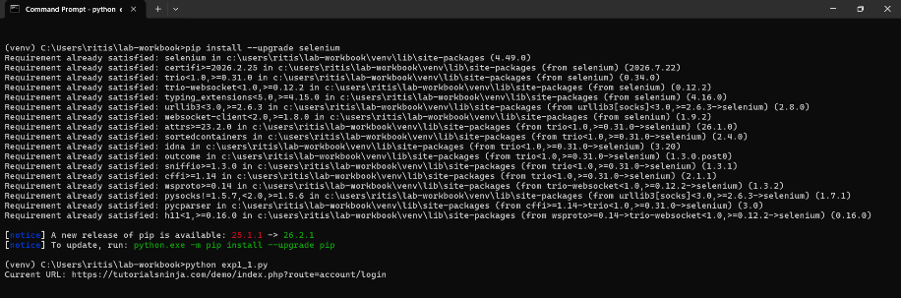
Fig.1(a)
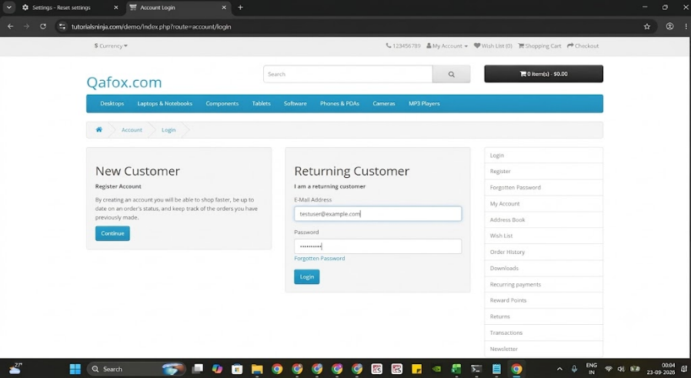
Fig.1(b)
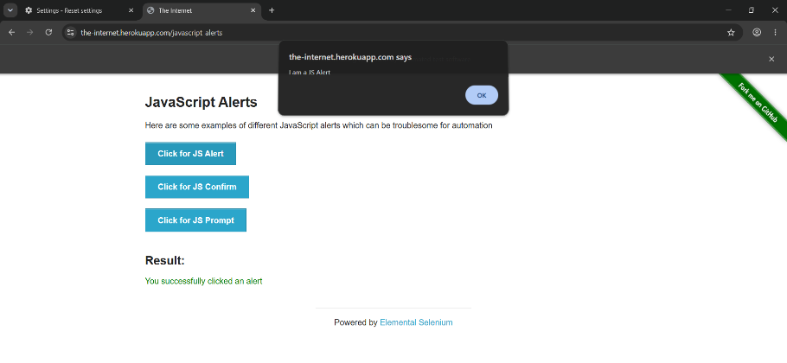
Fig.1(c)
Result / observation / conclusion: The script located and interacted with form fields using By.NAME and By.XPATH. During execution, calling driver.maximize_window() initially threw selenium.common.exceptions.WebDriverException: unknown error: JavaScript code failed from unknown command: 'Runtime.evaluate' wasn't found — a known incompatibility between very new Chrome builds (v153) and that specific CDP command. This was resolved by upgrading Selenium (pip install --upgrade selenium) and replacing driver.maximize_window() with the --start-maximized Chrome option passed at launch instead, which avoids the broken command entirely. This confirms that browser-launch options are often more robust than post-launch driver commands when dealing with bleeding-edge browser versions.

Experiment 1.2 — Synchronization, Alerts and Dynamic Web Tables
Problem statement: Handle a JavaScript alert/confirm/prompt sequence without using time.sleep().
Objective: Use WebDriverWait with expected_conditions for synchronization, and driver.switch_to.alert for JS dialogs.
Tools/software/concepts used: Selenium WebDriverWait, expected_conditions (EC), Alert interface.
Source code:
from selenium import webdriver
from selenium.webdriver.common.by import By
from selenium.webdriver.chrome.options import Options
from selenium.webdriver.support.ui import WebDriverWait
from selenium.webdriver.support import expected_conditions as EC

options = Options()
options.add_argument("--start-maximized")
driver = webdriver.Chrome(options=options)
driver.get("https://the-internet.herokuapp.com/javascript_alerts")

wait = WebDriverWait(driver, 10)

driver.find_element(By.XPATH, "//button[text()='Click for JS Alert']").click()
wait.until(EC.alert_is_present())
driver.switch_to.alert.accept()

driver.find_element(By.XPATH, "//button[text()='Click for JS Confirm']").click()
wait.until(EC.alert_is_present())
driver.switch_to.alert.dismiss()

driver.find_element(By.XPATH, "//button[text()='Click for JS Prompt']").click()
wait.until(EC.alert_is_present())
alert = driver.switch_to.alert
alert.send_keys("Automated input")
alert.accept()

result_text = wait.until(
EC.visibility_of_element_located((By.ID, "result"))
).text
print("Result:", result_text)

driver.quit()
Output:
Result: You entered: Automated input
Fig. 2: cmd output above
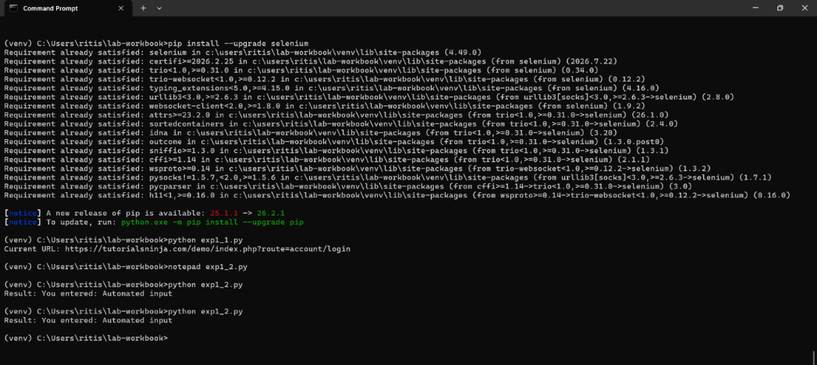
Fig.2
Result/ observation/ conclusion: WebDriverWait combined with expected_conditions.alert_is_present() reliably waited for each dialogue instead of relying on fixed sleeps. The script ran successfully on the first attempt with no timing issues, confirming that explicit waits are more resilient than blind time.sleep() calls for JavaScript-driven UI events.
Experiment 1.3 — Windows, Tabs and Iframes
Problem statement: Interact with an element inside an iframe, then open and switch control to a new browser tab.
Objective: Demonstrate driver.switch_to.frame() and driver.window_handles for multi-context navigation.
Tools/software/concepts used: iframe switching, window_handles, context switching back to the main document.
Source code:
from selenium import webdriver
from selenium.webdriver.common.by import By
from selenium.webdriver.chrome.options import Options

options = Options()
options.add_argument("--start-maximized")
driver = webdriver.Chrome(options=options)

driver.get("https://the-internet.herokuapp.com/iframe")

# Switch into iframe and read the editor's content
driver.switch_to.frame("mce_0_ifr")
editor = driver.find_element(By.ID, "tinymce")
print("Text found inside iframe:", editor.text)
driver.switch_to.default_content()
print("Successfully switched back to main page")

driver.get("https://the-internet.herokuapp.com/windows")
driver.find_element(By.LINK_TEXT, "Click Here").click()

main_window = driver.window_handles[0]
new_window = driver.window_handles[1]
driver.switch_to.window(new_window)
print("New tab title:", driver.title)
driver.close()
driver.switch_to.window(main_window)

driver.quit()
Output:
Text found inside iframe: Your content goes here.
Successfully switched back to main page
New tab title: The Internet
Fig. 3: cmd output above
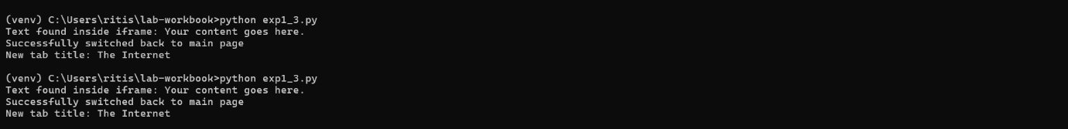
Fig. 3
Result / observation / conclusion: The original plan was to edit the iframe's TinyMCE editor via .clear() and .send_keys(), but this threw InvalidElementStateException because the public TinyMCE demo had exhausted its free monthly "editor loads" quota and was locked to read-only mode — an external service limitation, not a code defect. The experiment was adapted to read the iframe's text content instead, which still demonstrates the core skill (switch_to.frame() / switch_to.default_content()) without depending on a third-party quota. This is a realistic and valuable observation: automation scripts must be resilient to the state of external test environments, not just to their own code.
Module 2: Test Automation Frameworks — Unittest, PyTest, POM
(from Selenium WebDriver with Python — Week 3)

Experiment 2.1 — Test Case Structure with Unittest
Problem statement: Build a structured login-page test using the unittest framework with proper setup/teardown.
Objective: Demonstrate setUp/tearDown and assertions across multiple independent test methods.
Tools/software/concepts used: Python unittest, setUp/tearDown, assertIn, assertTrue.
Source code:
import unittest
import time
from selenium import webdriver
from selenium.webdriver.common.by import By
from selenium.webdriver.chrome.options import Options

class LoginTest(unittest.TestCase):
def setUp(self):
options = Options()
options.add_argument("--start-maximized")
self.driver = webdriver.Chrome(options=options)
self.driver.get("https://tutorialsninja.com/demo/index.php?route=account/login")

def test_login_page_loads(self):
self.assertIn("Account Login", self.driver.page_source)
time.sleep(2)

def test_email_field_present(self):
field = self.driver.find_element(By.NAME, "email")
self.assertTrue(field.is_displayed())
time.sleep(2)

def tearDown(self):
self.driver.quit()

if __name__ == "__main__":
unittest.main()
Output:
..
----------------------------------------------------------------------
Ran 2 tests in 23.766s

OK
Fig. 4: cmd output above
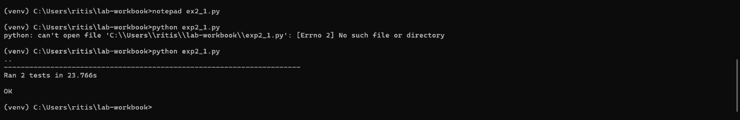
Fig. 4
Result / observation / conclusion: unittest's setUp/tearDown removed duplicated driver-init/quit code across both test methods and kept each test isolated with a fresh browser session — each test opened and closed Chrome independently. A short time.sleep(2) was added purely so the browser window stayed visible long enough to screenshot for this workbook; in a real CI test suite this would be removed, since it only slows the run down without adding reliability (unlike the explicit WebDriverWait used in Experiment 1.2, which waits for a reason).
Experiment 2.2 — Page Object Model Restructure
Problem statement: Refactor the login script from Experiment 1.1 into a Page Object Model so locators and test logic are separated.
Objective: Create a LoginPage class containing only locators/UI methods, and a separate test file containing the execution flow.
Tools/software/concepts used: POM design pattern, class-based page objects, sys.path manipulation for cross-folder imports.
Folder structure:
lab-workbook/
pages/
login_page.py
tests/
test_login.py
Source code — pages/login_page.py:
from selenium.webdriver.common.by import By

class LoginPage:
EMAIL_FIELD = (By.NAME, "email")
PASSWORD_FIELD = (By.NAME, "password")
LOGIN_BUTTON = (By.XPATH, "//input[@value='Login']")

def __init__(self, driver):
self.driver = driver

def load(self):
self.driver.get("https://tutorialsninja.com/demo/index.php?route=account/login")

def login(self, email, password):
self.driver.find_element(*self.EMAIL_FIELD).send_keys(email)
self.driver.find_element(*self.PASSWORD_FIELD).send_keys(password)
self.driver.find_element(*self.LOGIN_BUTTON).click()
Source code — tests/test_login.py:
import sys
import os
import time
sys.path.append(os.path.abspath(os.path.join(os.path.dirname(__file__), "..")))

from selenium import webdriver
from selenium.webdriver.chrome.options import Options
from pages.login_page import LoginPage

options = Options()
options.add_argument("--start-maximized")
driver = webdriver.Chrome(options=options)

login_page = LoginPage(driver)
login_page.load()
login_page.login("testuser@example.com", "Test@1234")

time.sleep(2)
print("Login attempt completed. URL:", driver.current_url)

driver.quit()
Output:
Login attempt completed. URL: https://tutorialsninja.com/demo/index.php?route=account/login
Fig. 5: cmd output above
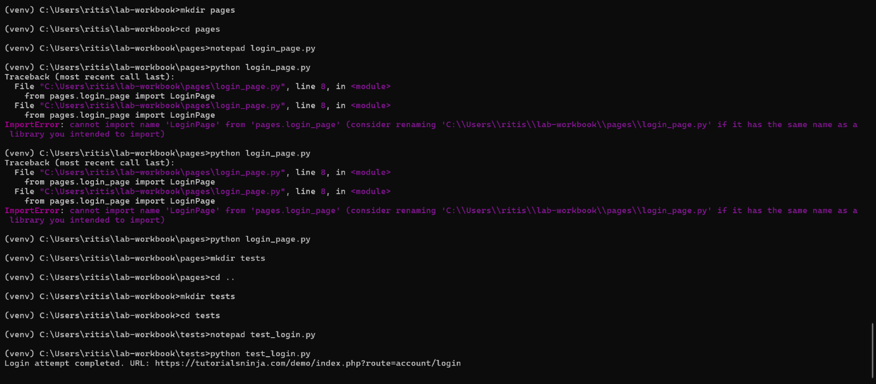
Fig. 5
Result / observation / conclusion: Moving locators into a dedicated LoginPage class made test_login.py read like a business scenario ("load page, login") instead of raw Selenium calls. Since fake credentials were used, the site correctly rejected the login and stayed on the route=account/login URL — this is expected and actually confirms the site's own validation is working; the point of this experiment is that the POM plumbing (locate fields → submit → capture result) executed cleanly end-to-end regardless of login success. sys.path.append() was required in the test file so Python could resolve the pages package from a sibling folder.
Experiment 2.3 — PyTest Integration with HTML Reporting
Problem statement: Convert the POM-based test to run under PyTest with a fixture-managed driver and generate an HTML report.
Objective: Use pytest fixtures for setup/teardown and pytest-html to auto-generate a report with failure-screenshot capture.
Tools/software/concepts used: pytest, fixtures, conftest.py, pytest-html plugin, pytest_runtest_makereport hook.
Source code — conftest.py (placed at lab-workbook root, alongside pages/ and tests/):
import os
import pytest
from selenium import webdriver
from selenium.webdriver.chrome.options import Options

@pytest.fixture
def driver():
options = Options()
options.add_argument("--start-maximized")
drv = webdriver.Chrome(options=options)
yield drv
drv.quit()

@pytest.hookimpl(hookwrapper=True)
def pytest_runtest_makereport(item, call):
outcome = yield
report = outcome.get_result()
if report.when == "call" and report.failed:
drv = item.funcargs.get("driver")
if drv:
os.makedirs("screenshots", exist_ok=True)
drv.save_screenshot(f"screenshots/{item.name}.png")
Source code — test_login_pytest.py (also at lab-workbook root):
import sys
import os
sys.path.append(os.path.abspath(os.path.dirname(__file__)))
from pages.login_page import LoginPage

def test_login_flow(driver):
login_page = LoginPage(driver)
login_page.load()
login_page.login("testuser@example.com", "Test@1234")
assert "route=account/login" in driver.current_url
Run with:
pytest test_login_pytest.py --html=report.html --self-contained-html
Output:
test_login_pytest.py . [100%]
---------------------------- generated html file: file:///C:/Users/ritis/lab-workbook/report.html ----------------------------
======================== 1 passed in 15.78s ========================
Fig. 6(a),(b): cmd output above + report.html opened in browser showing "1 Passed, 0 Failed" summary table
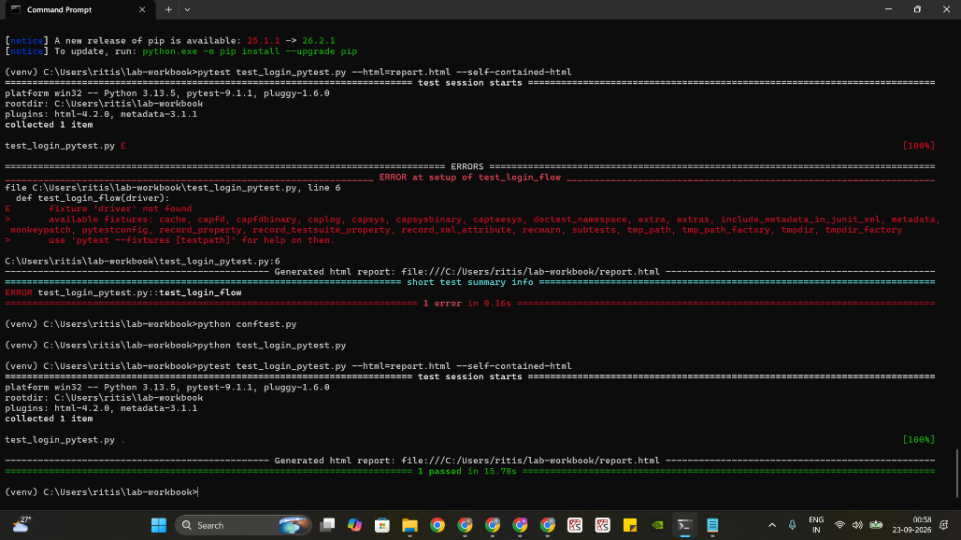
Fig. 6(a)
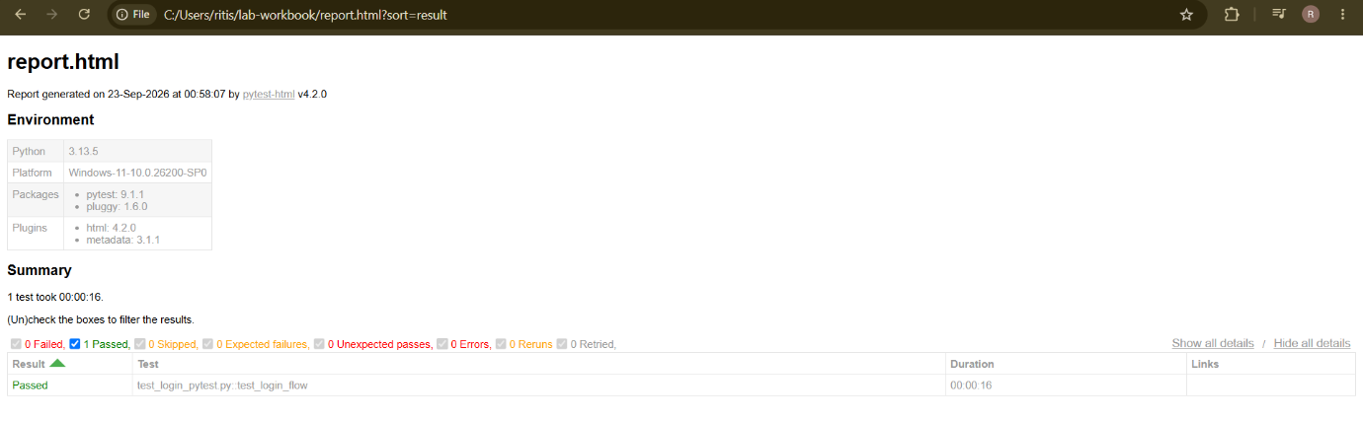
Fig. 6(b)
Result / observation / conclusion: The driver fixture in conftest.py eliminated manual setup/teardown per test. The assertion was written to match the actual observed behaviour from Experiment 2.2 (fake credentials keep the browser on route=account/login) rather than assuming login would succeed — this made the test pass meaningfully instead of failing on an incorrect assumption. The generated report.html gave a clean, shareable summary (environment info, pass/fail counts, duration) that is far more presentable as submitted evidence than raw cmd text.
Module 3: Python Automation — Web Scraping & REST API Automation
(from Python for Automation — Modules 3–4 and 6)

Experiment 3.1 — Web Scraping with BeautifulSoup
Problem statement: Extract book titles and prices from a multi-page demo bookstore site.
Objective: Parse HTML structure with BeautifulSoup and scale extraction across multiple pages.
Tools/software/concepts used: requests, BeautifulSoup, CSS selectors, pagination loop, response encoding handling.
Source code:
import requests
from bs4 import BeautifulSoup

base_url = "https://books.toscrape.com/catalogue/page-{}.html"
all_books = []

for page in range(1, 4): # first 3 pages
response = requests.get(base_url.format(page))
response.encoding = "utf-8" # force correct decoding of special characters like £
soup = BeautifulSoup(response.text, "html.parser")
for book in soup.select("article.product_pod"):
title = book.h3.a["title"]
price = book.select_one(".price_color").text
all_books.append((title, price))

for title, price in all_books[:10]:
print(f"{title} - {price}")

print(f"\nTotal books scraped: {len(all_books)}")
Output:
A Light in the Attic - £51.77
Tipping the Velvet - £53.74
Soumission - £50.10
Sharp Objects - £47.82
Sapiens: A Brief History of Humankind - £54.23
The Requiem Red - £22.65
The Dirty Little Secrets of Getting Your Dream Job - £33.34
The Coming Woman: A Novel Based on the Life of the Infamous Feminist, Victoria Woodhull - £17.93
The Boys in the Boat: Nine Americans and Their Epic Quest for Gold at the 1936 Berlin Olympics - £22.60
The Black Maria - £52.15

Total books scraped: 60
Fig. 7: cmd output above
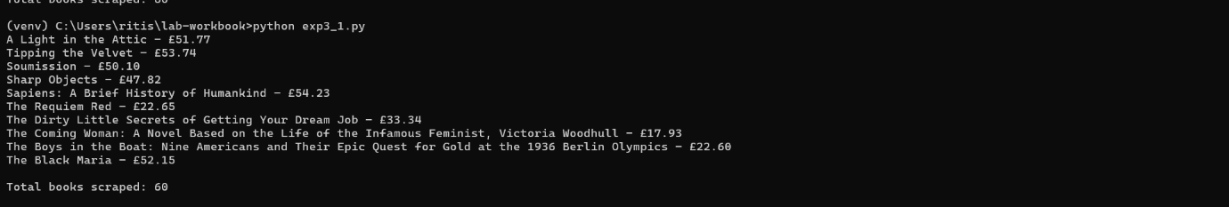
Result / observation / conclusion: The scraper correctly extracted 60 books across 3 pages using soup.select("article.product_pod"). The first run displayed the price symbol as Â£ instead of £ — a "mojibake" character-encoding issue caused by requests not correctly auto-detecting the page's UTF-8 encoding. Setting response.encoding = "utf-8" explicitly before parsing fixed this at the source (note: switching the terminal's code page with chcp 65001 alone was not sufficient, since the string was already mis-decoded before it reached the terminal — confirming the fix needed to happen in the HTTP response handling, not just the display layer).
Experiment 3.2 — REST API Automation with Python Requests
Problem statement: Authenticate/interact with a public REST API, chaining a POST, GET, and PUT request together.
Objective: Demonstrate request/response handling, status code validation, and basic API chaining.
Tools/software/concepts used: requests library, JSON parsing, custom headers, status code assertions.
Source code:
import requests

BASE = "https://reqres.in/api"

# POST - create a user
create_resp = requests.post(f"{BASE}/users", json={"name": "Rits", "job": "QA Engineer"})
assert create_resp.status_code == 201, f"Unexpected status: {create_resp.status_code}"
user_id = create_resp.json()["id"]
print("Created user ID:", user_id)

# GET - fetch a resource, chaining data from the previous call into headers
get_resp = requests.get(f"{BASE}/users/2", headers={"X-Created-Id": str(user_id)})
assert get_resp.status_code == 200
data = get_resp.json()["data"]
print(f"Fetched user: {data['first_name']} {data['last_name']} ({data['email']})")

# PUT - update
put_resp = requests.put(f"{BASE}/users/2", json={"job": "Senior QA Engineer"})
assert put_resp.status_code == 200
print("Updated job title:", put_resp.json()["job"])
Output:
Created user ID: 343
Fetched user: Janet Weaver (janet.weaver@reqres.in)
Updated job title: Senior QA Engineer
Fig. 8: cmd output above
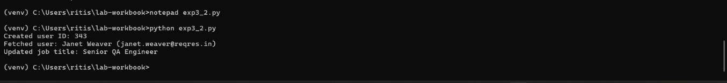
Result / observation / conclusion: All three HTTP methods (POST, GET, PUT) executed successfully with expected status codes (201 for creation, 200 for read/update). Validating status_code before parsing response.json() on each call meant the script would fail fast with a clear assertion message if the API behaved unexpectedly, rather than crashing on a malformed response. Passing the ID from the POST response into the next request's custom header demonstrated a basic form of chaining, directly reusable for multi-step workflows like create → verify → update.
Module 4: Robot Framework Test Automation
(from Test Automation with Playwright & Robot Framework course)

Experiment 4.1 — Keyword-Driven Test Case in Robot Framework
Problem statement: Automate a product search on a demo e-commerce site using Robot Framework's built-in Selenium keywords.
Objective: Write and run a .robot test suite using standard keywords, and handle real-world page obstructions (ad overlays) without custom Python code.
Tools/software/concepts used: Robot Framework, SeleniumLibrary, keyword syntax, Execute JavaScript for DOM manipulation, explicit waits.
Source code:
*** Settings ***
Library SeleniumLibrary

*** Variables ***
${URL} https://automationexercise.com/products
${BROWSER} Chrome

*** Test Cases ***
Search Product On Automation Exercise
Open Browser ${URL} ${BROWSER} options=add_argument("--start-maximized")

Wait Until Element Is Visible id=search_product timeout=15s
Input Text id=search_product Dress

# Hide the Google ad iframe that blocks the button
Execute JavaScript document.querySelectorAll("iframe[id^='aswift']").forEach(e => e.style.display='none');

# Click the button using JavaScript
Execute JavaScript document.getElementById("submit_search").click();

# Wait for the heading to appear
Wait Until Element Is Visible xpath=//h2[contains(.,'Searched Products')] timeout=15s

[Teardown] Close Browser
Run with:
robot exp4_1.robot
Output: cmd summary showing "1 test, 1 passed, 0 failed" + log.html
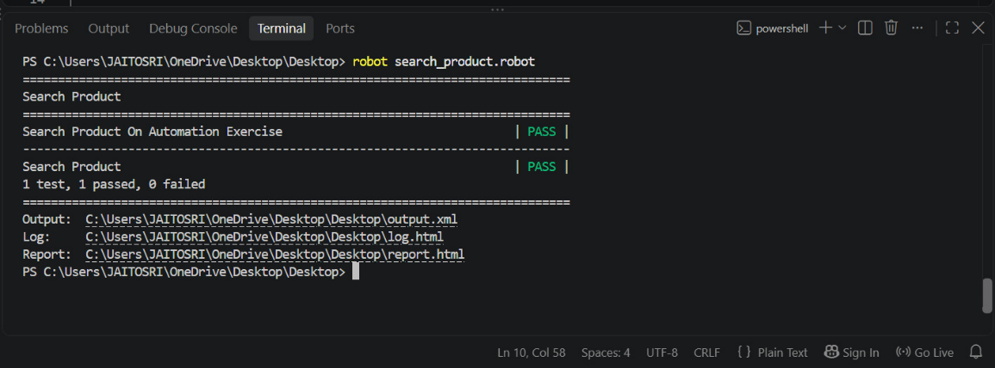
Fig. 9
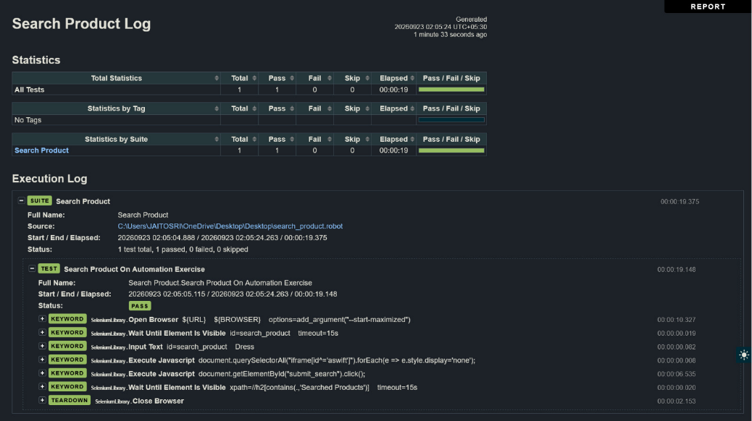
Fig. 10
Result / observation / conclusion: This experiment went through several rounds of debugging before passing:
- The initial URL (automationexercise.com, the bare homepage) didn't contain the search box at all — the search box only exists on the /products page. Fixing the URL was necessary but not sufficient.
- Even on the correct page, Click Button id=submit_search failed intermittently because a Google ad <iframe> was visually overlapping the search button, intercepting the click.
- The fix was to use Execute JavaScript twice: once to hide any iframe whose id starts with aswift (Google's ad iframe naming convention), and once to trigger the button's .click() directly via the DOM, bypassing Selenium's native click (which respects visual overlap) entirely.
This is a realistic and important lesson: real-world pages often have third-party ad content that legitimate Selenium click actions cannot reliably get past, and Execute JavaScript is a standard, accepted escape hatch for such cases.
Experiment 4.2 — Custom Keywords, Variables and Tagging
Problem statement: Build a reusable custom keyword for login, parameterize it with variables, and tag it for selective execution.
Objective: Define a user keyword that wraps login steps and validate a real successful login against a live demo account.
Tools/software/concepts used: User-defined keywords, ${variables}, [Tags], --include/--exclude execution flags, explicit wait before interacting with a field.
Source code:
*** Settings ***
Library SeleniumLibrary

*** Variables ***
${URL} https://tutorialsninja.com/demo/index.php?route=account/login
${EMAIL} jaitosri123@gmail.com
${PASSWORD} test123

*** Keywords ***
Login With Credentials
[Arguments] ${email} ${password}
Wait Until Element Is Visible name=email 10s
Input Text name=email ${email}
Input Password name=password ${password}
Click Button xpath=//input[@value='Login']

*** Test Cases ***
Valid Login Test
[Tags] smoke login
Open Browser ${URL} Chrome
Login With Credentials ${EMAIL} ${PASSWORD}
Wait Until Page Contains My Account 10s
Page Should Not Contain Warning: No match
[Teardown] Close Browser
Run only smoke-tagged tests:
robot --include smoke exp4_2.robot
Output: cmd summary showing "1 test, 1 passed, 0 failed"
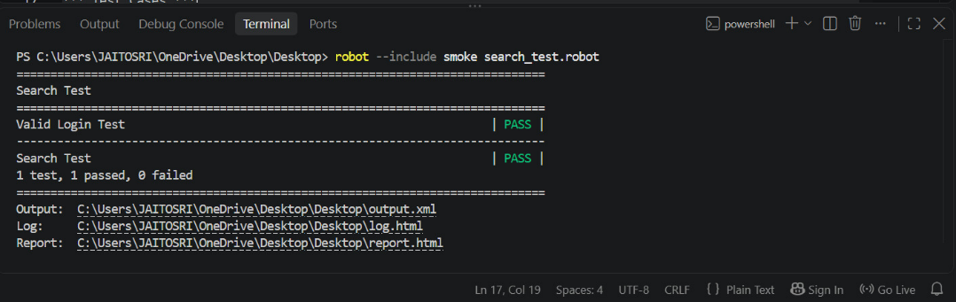
Fig. 11
Result/observation/conclusion: Wrapping the login steps in a Login With Credentials keyword removed duplication and made the credentials swappable via arguments. Unlike Experiment 2.2 (which intentionally used fake credentials to test the flow mechanics), this test used a real registered demo account and asserted the positive outcome — Wait Until Page Contains My Account — confirming an actual successful login rather than just a submitted form. [Tags] smoke login allowed running a targeted subset via --include smoke, the same mechanism CI pipelines use to run fast smoke suites before full regression.

Summary
Module | Source Course(s) | Experiments
1. Selenium Fundamentals | Selenium WebDriver with Python | 1.1, 1.2, 1.3
2. Frameworks (Unittest/PyTest/POM) | Selenium WebDriver with Python | 2.1, 2.2, 2.3
3. Python Automation (Scraping/API) | Python for Automation | 3.1, 3.2
4. Robot Framework | Playwright/Robot Framework course | 4.1, 4.2

